Grey Flexible Duct Hose
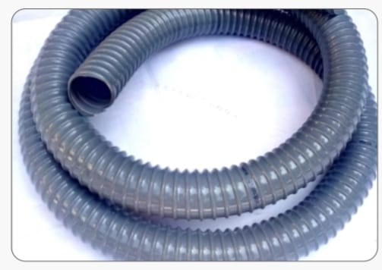

Structure:
Hose made of spiral reinforcement of rigid PVC into fine grade soft PVC. Made available in Grey. A Moderate flexible hose for collection and conveying of air, dust and light materials. Quality PVC compounding and production techniques have made the hose with better flexibility and service life than other commercial brands. PVC being chemically inert and inexpensive is still mostly preferred industrial duct hose. Temperature range - 60°C Colour - Grey

